Select:

- Python’s select() function is a direct interface to the underlying operating system implementation. It monitors sockets, open files, and pipes (anything with a fileno() method that returns a valid file descriptor) until they become readable or writable, or a communication error occurs.
- select() makes it easier to monitor multiple connections at the same time, and is more efficient than writing a polling loop in Python using socket timeouts, because the monitoring happens in the operating system network layer, instead of the interpreter.
- The arguments to select() are three lists containing communication channels to monitor. The first is a list of the objects to be checked for incoming data to be read, the second contains objects that will receive outgoing data when there is room in their buffer, and the third those that may have an error (usually a combination of the input and output channel objects). The next step in the server is to set up the lists containing input sources and output destinations to be passed to select().
- select() returns three new lists, containing subsets of the contents of the lists passed in. All of the sockets in the readable list have incoming data buffered and available to be read. All of the sockets in the writable list have free space in their buffer and can be written to. The sockets returned in exceptional have had an error (the actual definition of “exceptional condition” depends on the platform).
- The “readable” sockets represent three possible cases. If the socket is the main “server” socket, the one being used to listen for connections, then the “readable” condition means it is ready to accept another incoming connection. In addition to adding the new connection to the list of inputs to monitor, this section sets the client socket to not block.
- There are fewer cases for the writable connections. If there is data in the queue for a connection, the next message is sent. Otherwise, the connection is removed from the list of output connections so that the next time through the loop select() does not indicate that the socket is ready to send data.
- Finally, if there is an error with a socket, it is closed

Program :

server.py

import select
import socket
import sys
import queue
# Create a TCP/IP socket
server = socket.socket(socket.AF_INET, socket.SOCK_STREAM)
#non blocking socket
server.setblocking(0)
# Bind the socket to the port
server_address = ('localhost', 10001)
server.bind(server_address)
# Listen for incoming connections
server.listen(5)
# Sockets from which we expect to read
inputs = [ server ]
# Sockets to which we expect to write
outputs = [ ]
# Outgoing message queues (socket:Queue)
message_queues = {}
while inputs:
# Wait for at least one of the sockets to be ready for processing
print( '\nwaiting for the next event')
readable, writable, exceptional = select.select(inputs, outputs, inputs)
# Handle inputs
for s in readable:
if s is server:
# A "readable" server socket is ready to accept a connection
connection, client_address = s.accept()
print( 'new connection from', client_address)
connection.setblocking(0)
inputs.append(connection)
else:
data = s.recv(1024)
if data.decode():
# A readable client socket has data
print( 'received "%s" from %s' % (data.decode(), s.getpeername()))
message_queues[s]=data.decode()
# Add output channel for response
if s not in outputs:
outputs.append(s)
else:
# Interpret empty result as closed connection
print( 'closing', client_address, 'after reading no data')
# Stop listening for input on the connection
if s in outputs:
outputs.remove(s)
inputs.remove(s)
s.close()
# Remove message queue
del message_queues[s]
# Handle outputs
for s in writable:
try:
next_msg = message_queues[s]
except queue.Empty:
# No messages waiting so stop checking for writability.
print( 'output queue for', s.getpeername(), 'is empty')
outputs.remove(s)
else:
print( 'sending "%s" to %s' % (next_msg, s.getpeername()))
s.send(next_msg.encode())
# Handle "exceptional conditions"
for s in exceptional:
print( 'handling exceptional condition for', s.getpeername())
# Stop listening for input on the connection
inputs.remove(s)
if s in outputs:
outputs.remove(s)
s.close()
# Remove message queue
del message_queues[s]

client.py

import sys
import socket

messages = [ 'This is the message. ',
'It will be sent ',
'in parts.',
]
server_address = ('localhost', 10001)
# Create a TCP/IP socket
socks = [ socket.socket(socket.AF_INET, socket.SOCK_STREAM),
socket.socket(socket.AF_INET, socket.SOCK_STREAM),
socket.socket(socket.AF_INET, socket.SOCK_STREAM),
socket.socket(socket.AF_INET, socket.SOCK_STREAM)
]
# Connect the socket to the port where the server is listening
print( 'connecting to %s port %s' % server_address)
for s in socks:
s.connect(server_address)
for message in messages:
# Send messages on both sockets
for s in socks:
print( '%s: sending "%s"' % (s.getsockname(), message))
s.send(message.encode())
# Read responses on both sockets
for s in socks:
data = s.recv(1024)
print( '%s: received "%s"' % (s.getsockname(), data.decode()))
if not data.decode():
print( 'closing socket', s.getsockname())
s.close()

output :

server

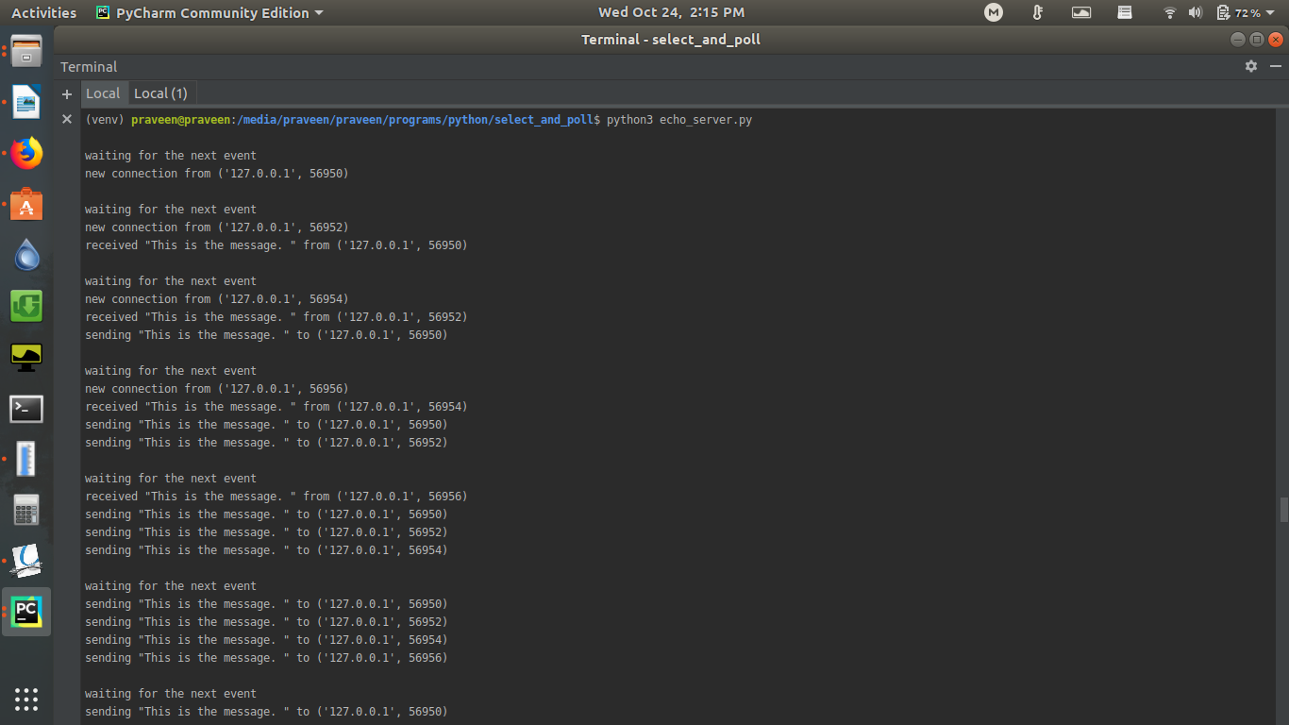
client
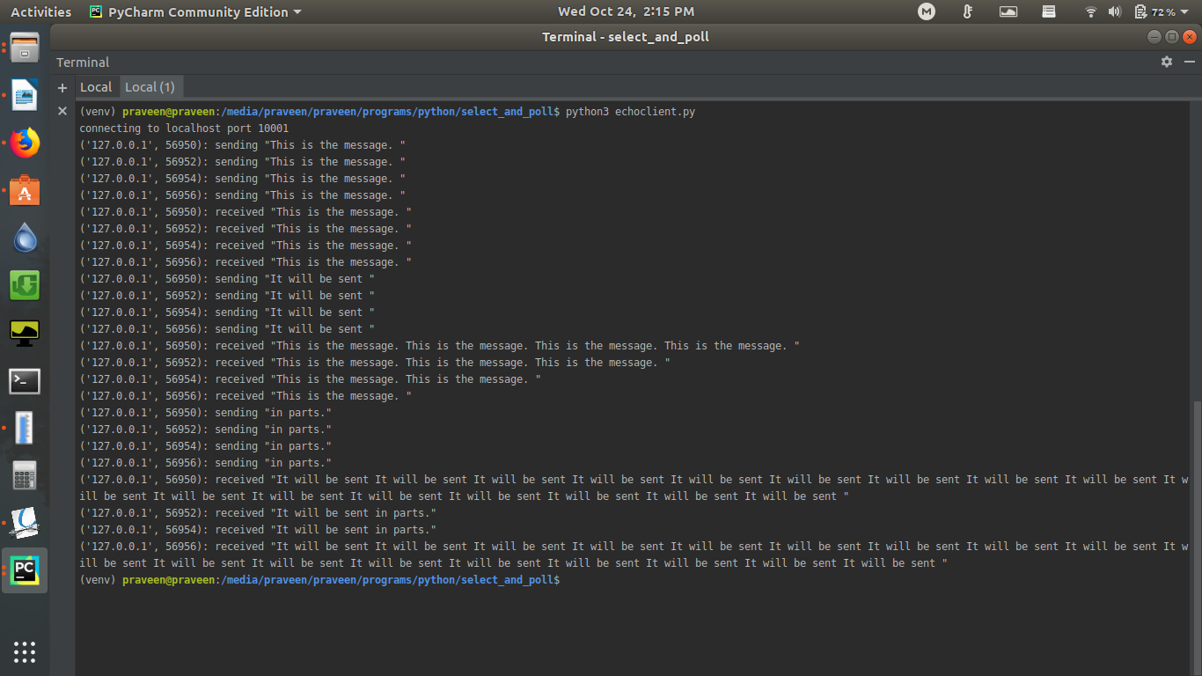

Poll:

- The poll() function provides similar features to select(), but the underlying implementation is more efficient. The trade-off is that poll() is not supported under Windows, so programs using poll() are less portable.
- poll() scales better because the system call only requires listing the file descriptors of interest, while select() builds a bitmap, turns on bits for the fds of interest, and then afterward the whole bitmap has to be linearly scanned again. select() is O(highest file descriptor), while poll() is O(number of file descriptors).
- Python implements poll() with a class that manages the registered data channels being monitored. Channels are added by calling register() with flags indicating which events are interesting for that channel. The full set of flags is:
Event | Description
POLLIN | Input ready
POLLPRI | Priority input ready
POLLOUT | Able to receive output
POLLERR | Error
POLLHUP | Channel closed
POLLNVAL | Channel not open

Program :

server.py

import select
import socket
import sys
import queue
# Create a TCP/IP socket
server = socket.socket(socket.AF_INET, socket.SOCK_STREAM)
server.setblocking(0)
# Bind the socket to the port
server_address = ('localhost', 10001)
print('starting up on %s port %s' % server_address)
server.bind(server_address)
# Listen for incoming connections
server.listen(5)
# Keep up with the queues of outgoing messages
message_queues = {}
# Do not block forever (milliseconds)
TIMEOUT = 1000
# Commonly used flag setes
READ_ONLY = select.POLLIN | select.POLLPRI | select.POLLHUP | select.POLLERR
READ_WRITE = READ_ONLY | select.POLLOUT
# Set up the poller
poller = select.poll()
poller.register(server, READ_ONLY)
# Map file descriptors to socket objects
fd_to_socket = { server.fileno(): server,
}
while True:
# Wait for at least one of the sockets to be ready for processing
print('\nwaiting for the next event')
events = poller.poll(TIMEOUT)
for fd, flag in events:
# Retrieve the actual socket from its file descriptor
s = fd_to_socket[fd]
# Handle inputs
if flag & (select.POLLIN | select.POLLPRI):
if s is server:
# A "readable" server socket is ready to accept a connection
connection, client_address = s.accept()
print('new connection from', client_address)
connection.setblocking(0)
fd_to_socket[connection.fileno()] = connection
poller.register(connection, READ_ONLY)
# Give the connection a queue for data we want to send
message_queues[connection] = queue.Queue()
#s is client
else:
data = s.recv(1024)
if data.decode():
# A readable client socket has data
print('received "%s" from %s' % (data.decode(), s.getpeername()))
message_queues[s]=data.decode()
# Add output channel for response
poller.modify(s, READ_WRITE)
else:
# Interpret empty result as closed connection
print('closing', client_address, 'after reading no data')
# Stop listening for input on the connection
poller.unregister(s)
s.close()
# Remove message queue
del message_queues[s]
elif flag & select.POLLOUT:
# Socket is ready to send data, if there is any to send.
try:
next_msg = message_queues[s]
except queue.Empty:
# No messages waiting so stop checking for writability.
print('output queue for', s.getpeername(), 'is empty')
poller.modify(s, READ_ONLY)
else:
print('sending "%s" to %s' % (next_msg, s.getpeername()))
s.send(next_msg.encode())

client.py

same client

Output :

poll_server:

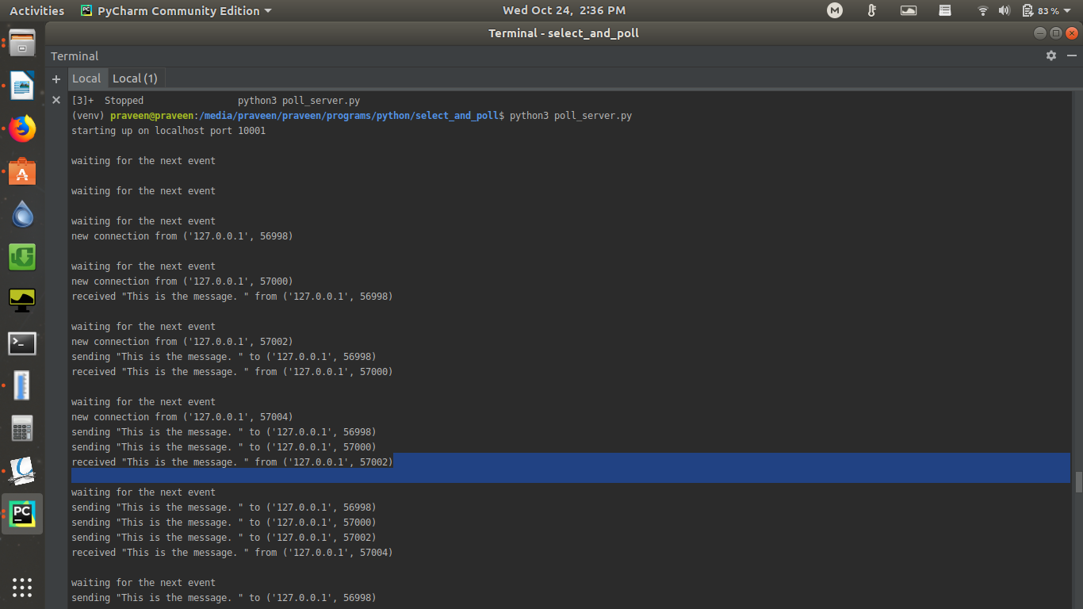
poll_client :

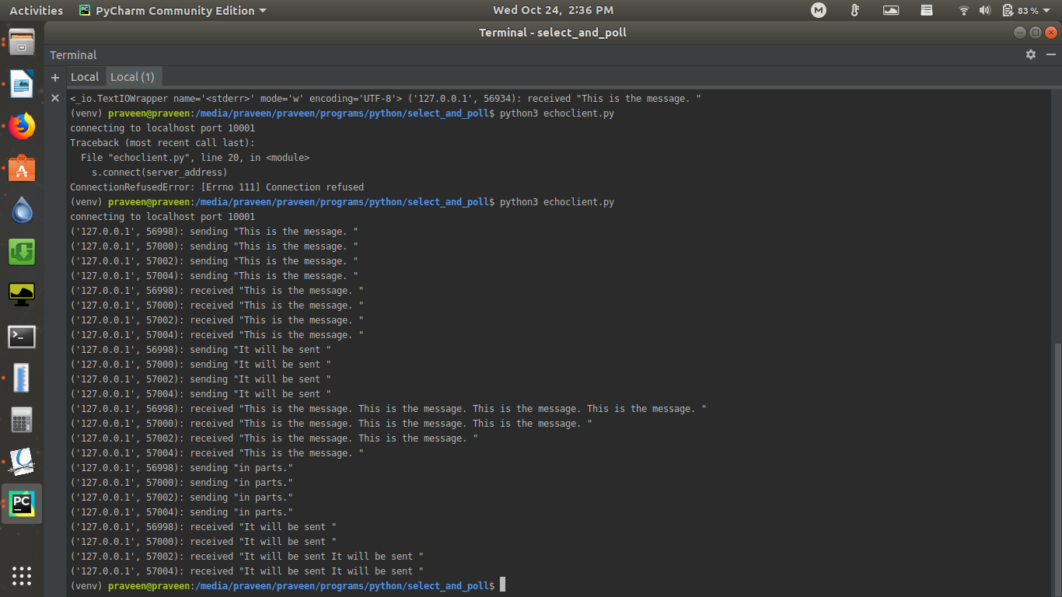
References:

1)https://pymotw.com/2/select/
2)https://docs.python.org/3/library/select.html#poll-objects

